**Marketing Campaign Analysis - SQL**

**Project Overview**

Our company has been running multiple marketing campaigns across various channels (Facebook, Instagram, Pinterest) to promote our products. We have collected detailed data on daily ad performance, including metrics like impressions, clicks, spend, conversions, and engagement (likes, shares, comments). This project aims to analyze this data to gain insights into the effectiveness of our campaigns, optimize our ad spend, and improve future marketing strategies.

**Business Questions**

1. **Campaign Performance:**
   * Which campaign generated the highest number of impressions, clicks, and conversions?

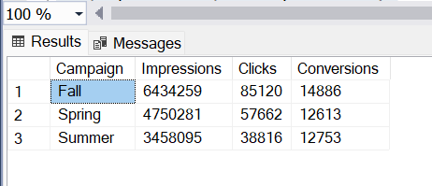

**Insight:** The Fall Campaign outperformed all other periods, generating the highest number of impressions, clicks, and conversions. In total, Fall recorded 6,434,259 impressions, 85,120 clicks, and 14,886 conversions, which indicate strong audience engagement and high conversion during the fall season.

* What is the average cost-per-click (CPC) and click-through rate (CTR) for each campaign?

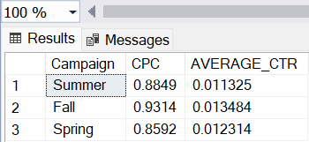

**Insight:** Fall had the highest Cost Per Click (CPC) at **$0.9314** and an Average Click-Through Rate (CTR) of **1.13%**. Summer followed with a CPC of **$0.8849** and CTR of **1.14%**, while Spring had the lowest CPC at **$0.8592** but the highest CTR at **1.23%**. These trends suggest that while Fall had the highest ad costs, Spring delivered the most efficient engagement in terms of CTR.

**2. Channel Effectiveness:**

* + Which channel has the highest ROI?

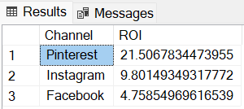

**Insight**: Pinterest has the highest Return on Investment (ROI) of 21.50 compared to the rest of the campaign showing strong cost efficiency and good revenue generation during this time.

* + How do impressions, clicks, and conversions vary across different channels?

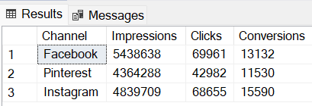

**Insight:**Facebook has 5,438,638 Impressions, 69,961 Clicks which is the highest compared to Instagram with 4,839,709 Impressions, 68,655 Clicks and Pinterest with 4,364,288 Impressions, 42,982 Clicks. However, Instagram has 15,590 Conversions which is the highest compared to Facebook with 13,132 Conversions and Pinterest with 11,530 Conversions. This shows Facebook had the most traffic while Instagram converted the most users.

**3. Geographical Insights:**

* + Which cities have the highest engagement rates (likes, shares, comments)?

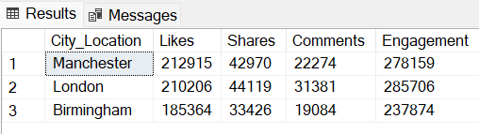

**Insight**: London has the highest overall engagement (285,706), followed by Manchester (278,159) and Birmingham (237,874).

* + What is the conversion rate by city?

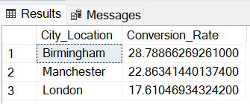

**Insight**: Birmingham has the highest overall conversion rate (28.78), followed by Manchester (22.86) and London (17.61)

**4. Device Performance:**

* + How do ad performances compare across different devices (mobile, desktop, tablet)?

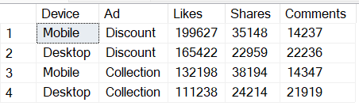

**Insight:**

**Ad Performance Across Devices**

Both the "Discount" ad and the "Collection" ad performed better on Mobile than on Desktop. Mobile devices generated higher engagement across all ad types, confirming that users are more active on mobile compared to desktops.

**Engagement Type Breakdown**

Discount ads have the highest likes which is the most common interaction indicating user appreciation while Collection has the highest share. This suggests that collection ads content is valuable enough to be shared but it may need adjustments in message or visuals to increase user interaction. However, comments are the least frequent engagement, implying that the ads may not be prompting much conversation or feedback.

* + Which device type generates the highest conversion rates?

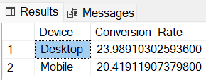

**Insight:** Desktop generated the highest conversion rate 0f 23.98%. This implies that ads are purchased more via desktop compared to mobile.

**5. Ad-Level Analysis:**

* + Which specific ads are performing best in terms of engagement and conversions?

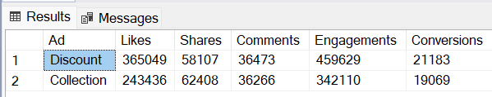

**Insight**: Discount ads are the best performing ads in terms of overall engagements(459,629) and conversions(21,183)

* + What are the common characteristics of high-performing ads?

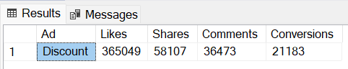

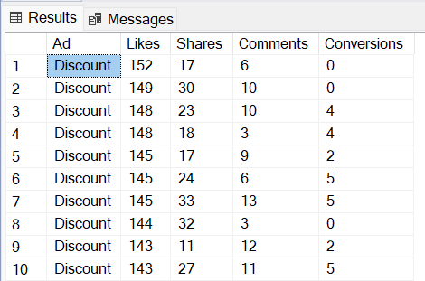

**Insight**: Discount Ad shows that it is high-performing having the highest number of Likes, Comments and Conversions.

**6. ROI Calculation:**

* + What is the ROI for each campaign, and how does it compare across different channels and devices?

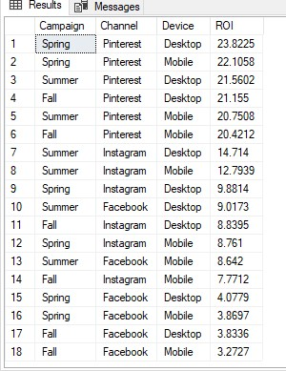

**Insight:** Spring recorded the highest ROI (23.82 from Pinterest on Desktop) but showed lower values across other platforms. Similarly, Summer demonstrated strong overall performance, with a high ROI from Pinterest. Fall maintained a competitive ROI, though slightly lower than Spring and Summer.

Pinterest emerged as the top-performing channel, particularly on Desktop, which indicates it being the primary driver of high ROI. In contrast, Facebook recorded the lowest ROI, suggesting it may not be the most effective platform for this campaign. Additionally, Desktop consistently outperformed Mobile, indicating that users on desktops are more likely to convert or engage profitably.

* How does spend correlate with conversion value across different campaigns?

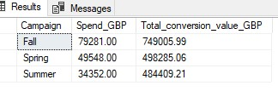

**Insight:** There is a positive correlation between Spend and Total Conversion Value across all campaigns, meaning that higher spending generally leads to higher conversion value. Fall exhibits the strongest correlation, while Summer shows relatively high efficiency despite lower spending.

**7. Time Series Analysis:**

* + Are there any noticeable trends or seasonal effects in ad performance over time?

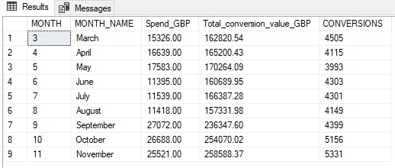

**Insight:** Early months from (March–August) show relatively stable but lower performance, suggesting a low ad strategy. Increased spending from September to November leads to higher conversions and conversion value. Ad performance improves in the later months of the year, likely due to seasonal demand.

**Recommendations**

1. Given that Fall generated the highest impressions, clicks, and conversions, allocate a higher budget for campaigns during this period to maximize engagement and ROI. Consider launching promotional offers or exclusive deals in Fall to capitalize on the strong seasonal demand.
2. Pinterest delivered the highest ROI, particularly on Desktop. Prioritize Pinterest ads for high-ROI campaigns, especially during Spring and Summer.
3. Facebook generated the most traffic but had the lowest ROI. Optimize Facebook campaigns by improving audience targeting and refining creatives to enhance conversion rates.
4. Since Instagram had the highest conversions, increased budget allocation for Instagram, particularly for high-intent audiences. Test Instagram-exclusive promotions to further boost conversion potential.
5. Discount ads had the highest engagement and conversions, suggesting strong appeal. Invest more in Discount ads while testing variations for further improvement. Since Collection ads had the highest shares but fewer interactions, adjust messaging to drive more direct engagement.
6. Since higher spending leads to higher conversion value, strategically increase budget allocation from September to November when ad performance peaks. Maintain steady but lower spending from March–August, using this period for testing new strategies.
7. London had the highest engagement, which can be improved by allocating more resources to ads in this city. Additionally, optimize ads Manchester and Birmingham by improving ads message and introducing a catchy call to action. Birmingham, despite lower engagement numbers, had a strong conversion rate. Test tailored messaging to further enhance performance.